How to generatet he APK package

Go to Buid 🡪 Generated Signed APK

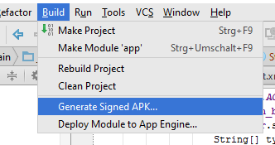

T o generatet he APK, a „Key store path“ has to be created or an existing one could be used.  
in order to create one, the button „Create new“ should be pressed (In the generate signed APK Wizard) and in the following screen, at least the Path, Password Alias and Organization should be filled.

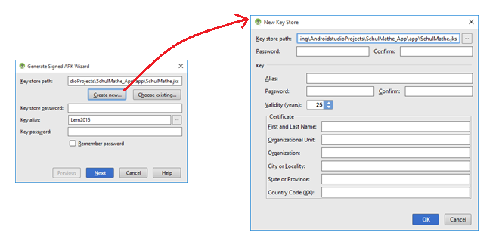

After we can continue working in the „Generate Signed APK Wizard“, here we need to create a „Kez store password“ and a „Key Alias“.  
  
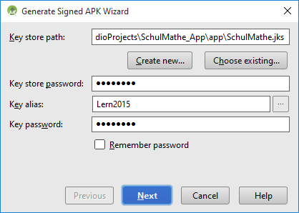

When we press next it ask for the master password to be entered (Lern2015)

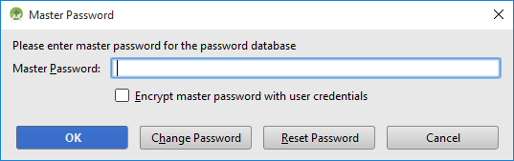

In newer versions os Andriod the following problem could occur:

Android Troubleshooting

1. Problem uploading APK to he store

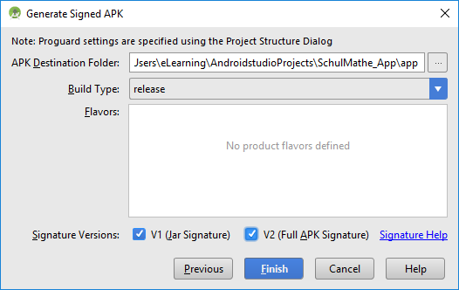

Allways check both types of signatures, otherwise there will be a problem when uploading the APK file in the store.